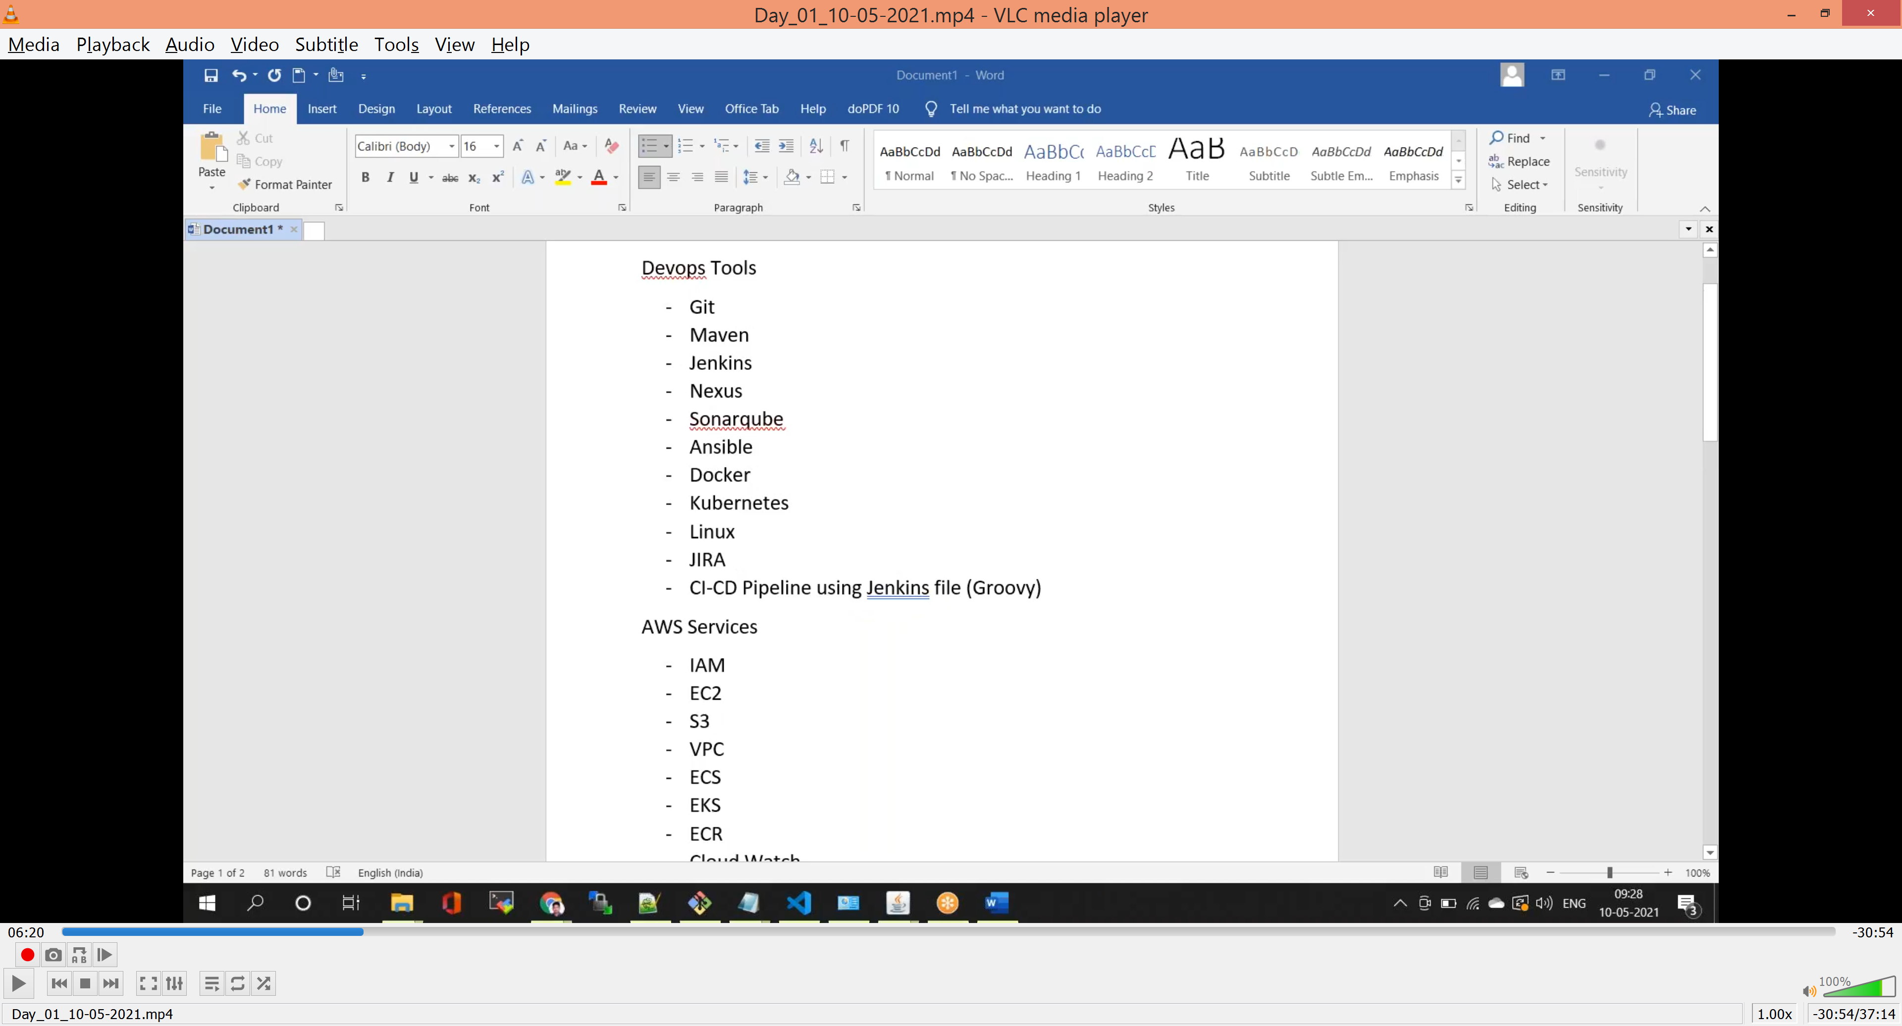

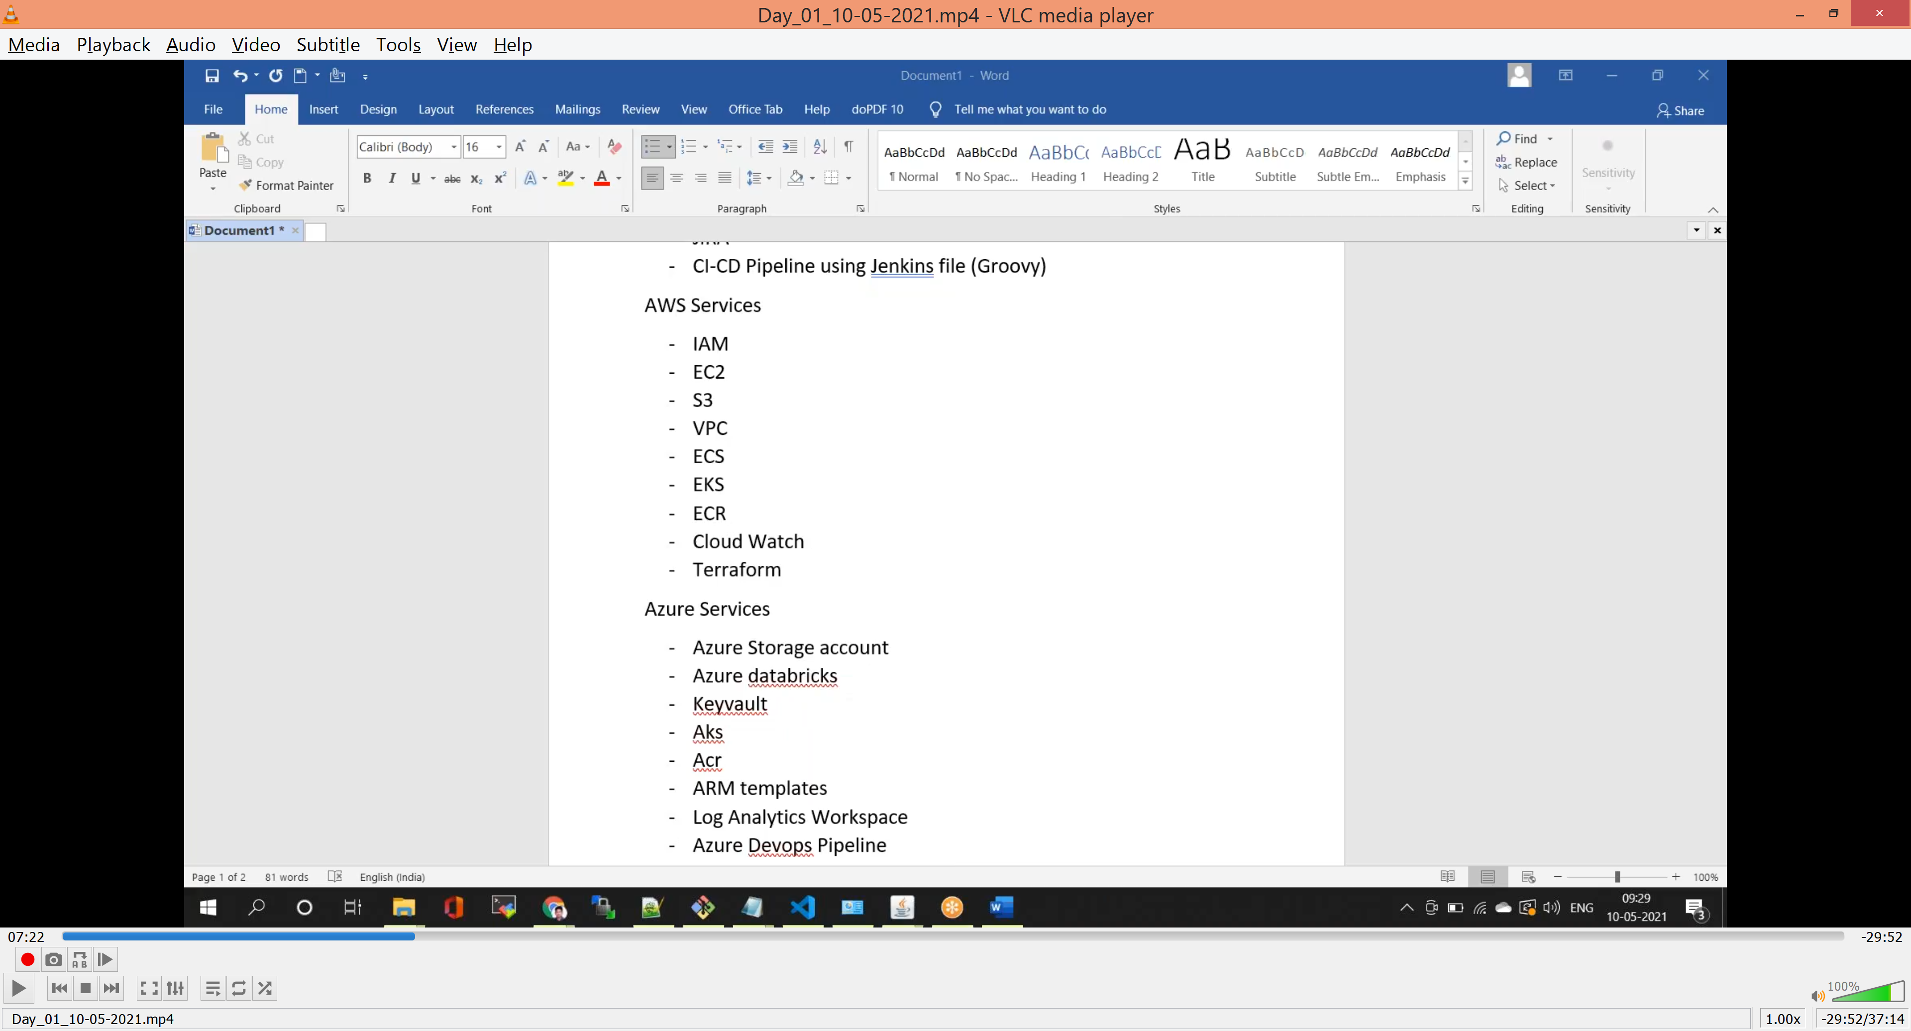

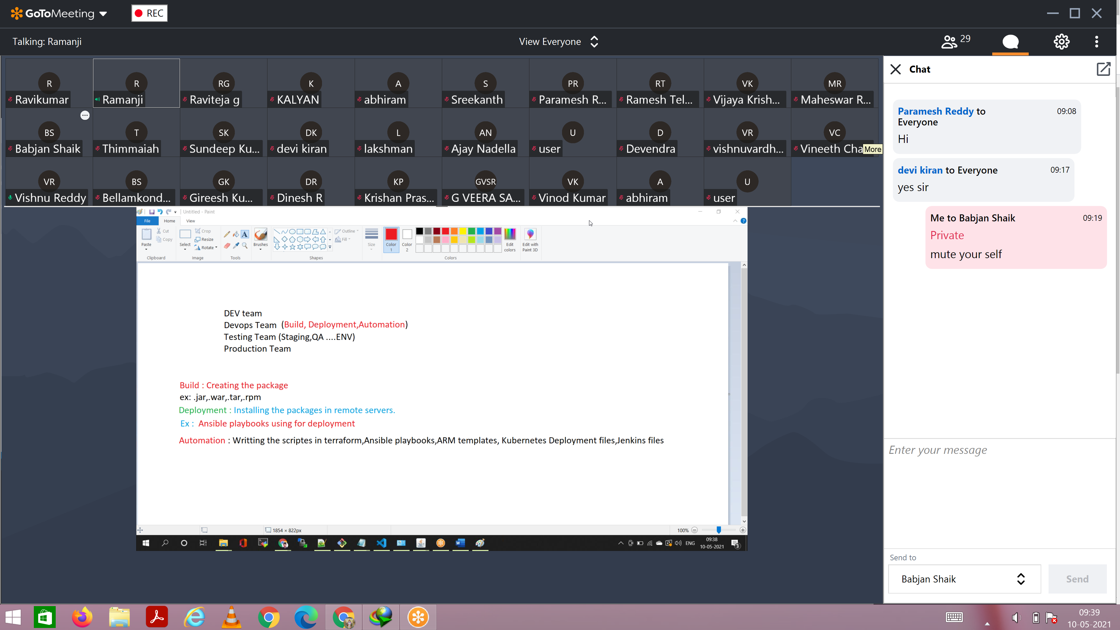

Build:-

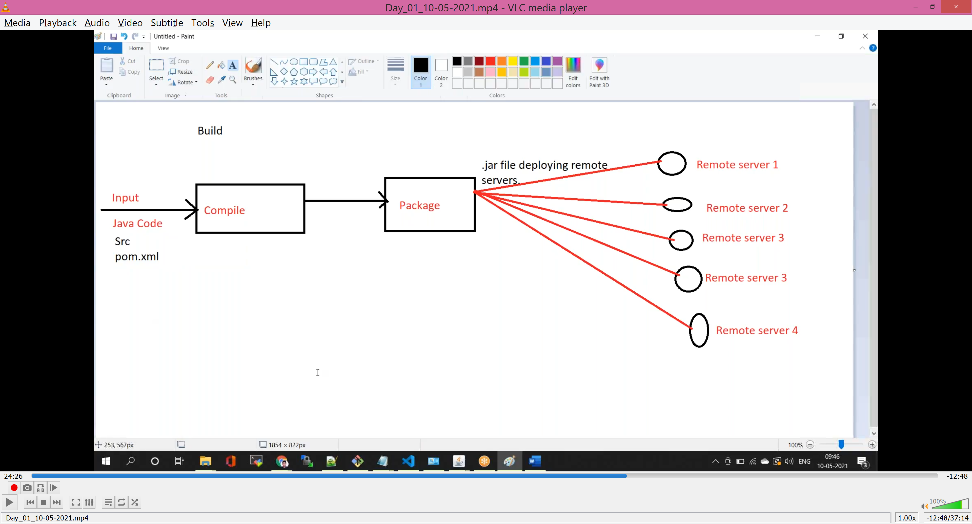

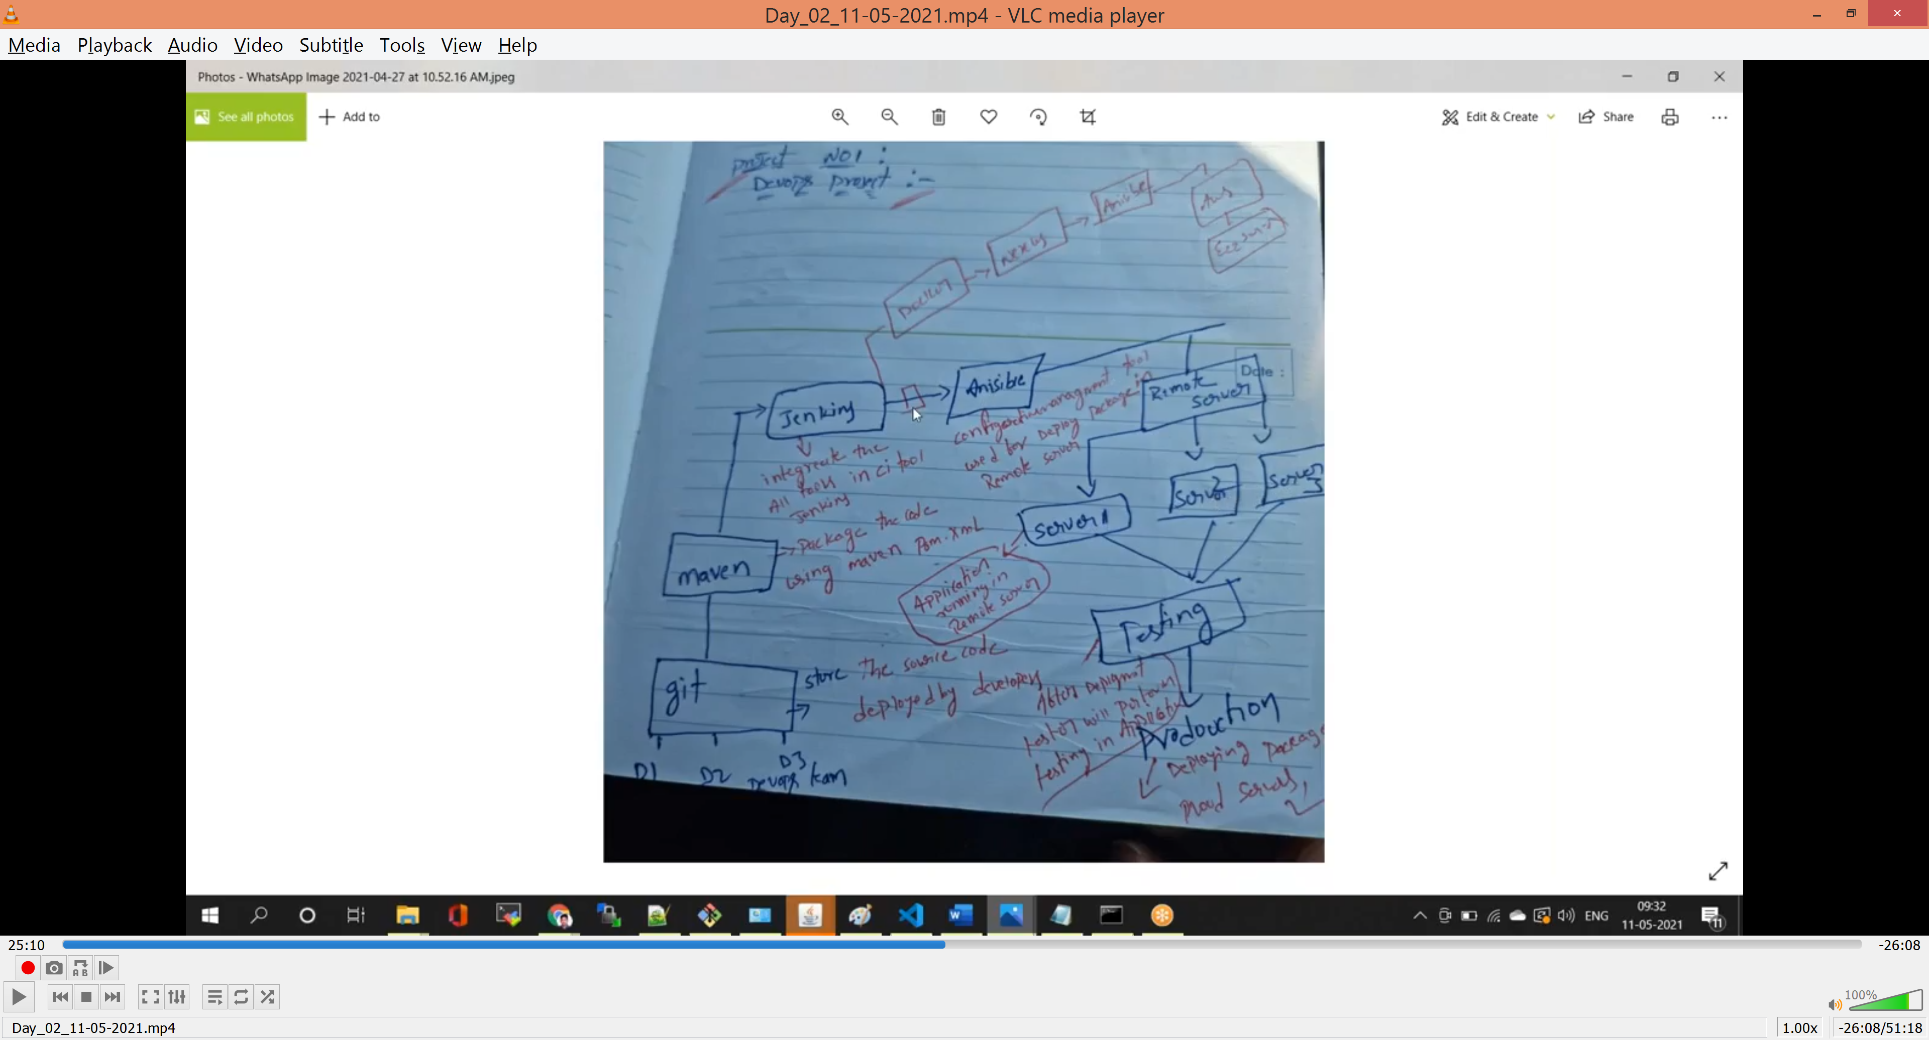

Configuration App:-

Puppet

Chef

Anisible

Rundeck

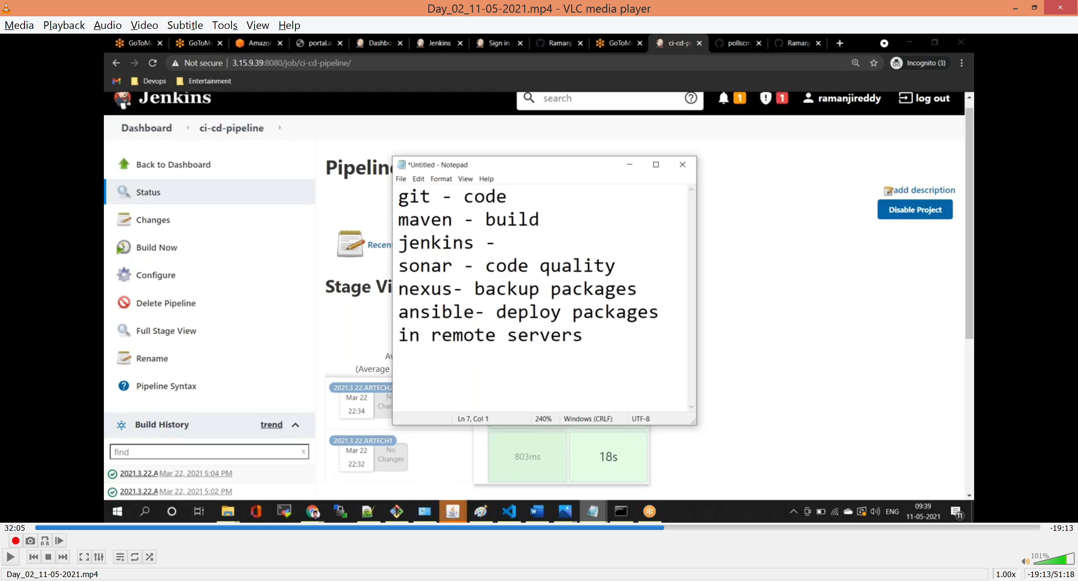

Linux Basic Commands

Mkdir ‘ to create the folder

cd <folder name> ‘to open folder

cd .. ‘one step back from current folder

cd ../.. ‘two step back

cd ../../.. ‘three step back

touch <file name> ‘ to create file

vim or vi <file name> ‘ to edit file

cat ‘it display content inside file

esc :wq! ‘save and quit the file

esc :q! ‘quite the file

rm –rf ‘to remove folder or file

sudo su ‘login as root user

chmod 777 ‘ to change the permission of file

ssh ‘ to connect the remote server

scp ‘to copy file from one server to other server

cp ‘copy file or folder one location to other location in same server

mv ‘move file or folder from one location to other location in same server

ls ‘to check the list of folders or files

ls -lart ‘to check the list of folders or files with hidden mode

pwd ‘to check the current path

Git Commands

- git clone <repository name> 'to clone the remote repository name

- git status 'to check untracked files status

- git add 'to add the untracked files

- git log 'to check history of logs

- git diff 'to see difference between two changes

- git checkout -b <new branch name> 'to create the new branch in git

- git branch 'to check the list of branches

- git delete origin <branch name> 'to delete remote branch

- git checkout <branch name> ‘to switch branch

- git commit –m “<Message>” ‘to commit the changes

- git push origin master ‘push the changes from local to remote repository

- git merge

- git pull <branch_name> <remote_URL/remote_name>

‘To get the latest version of a repository run *git pull*. This pulls the changes from the remote repository to the local computer.

- git fetch

- git pull request

- git reset

- git revert

- git stash ‘To save changes made when they’re not in a state to commit them to a repository. This will store the work and give a clean working directory. For instance, when working on a new feature that’s not complete, but an urgent bug needs attention.

# Store current work with untracked files

- git stash -u

# Bring stashed work back to the working directory

- git stash pop

git rm

Remove files or directories from the working index (staging area). With git rm, there are two options to keep in mind: force and cached. Running the command with force deletes the file. The cached command removes the file from the working index. When removing an entire directory, a recursive command is necessary.

Usage:

# To remove a file from the working index (cached):

$ git rm --cached <file name>

# To delete a file (force):

$ git rm -f <file name>

# To remove an entire directory from the working index (cached):

$ git rm -r --cached <directory name>

# To delete an entire directory (force):

$ git rm -r -f <file name>

-------------------------------------------------------------------------------------------------------------------------------------

Git Repository

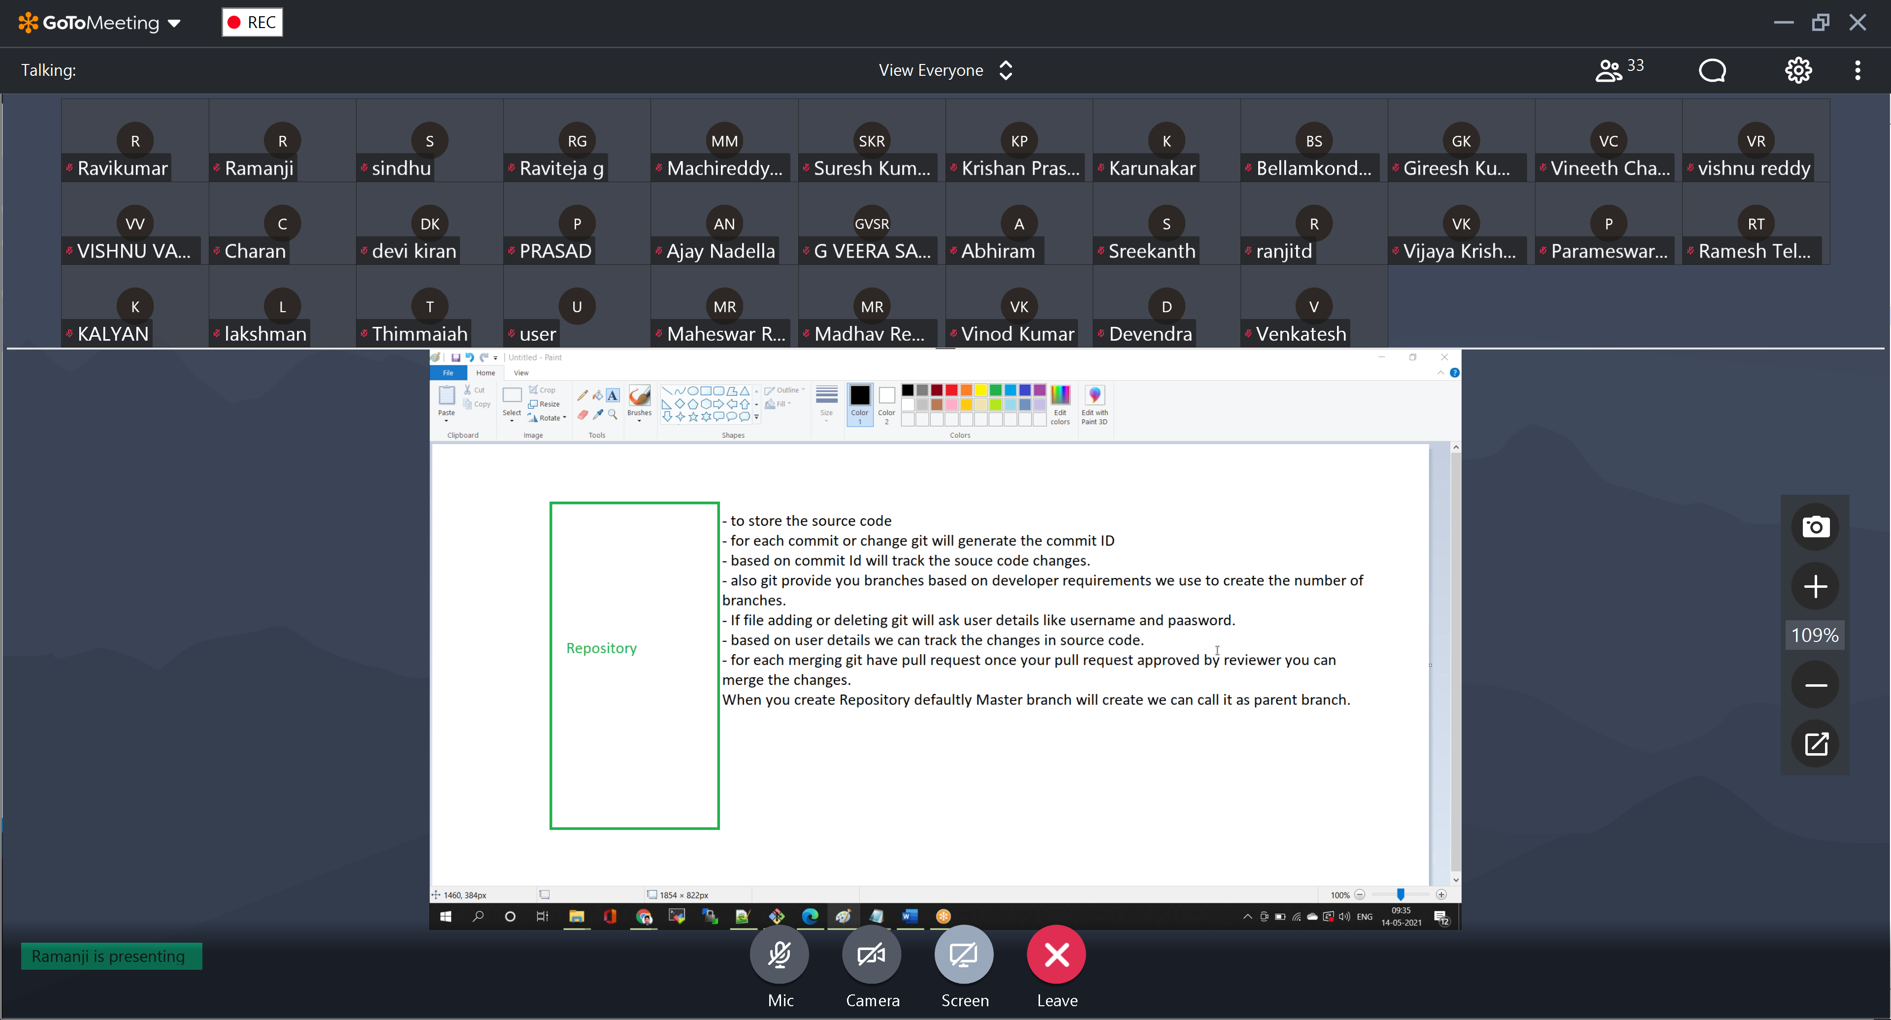

Interview Questions

Which architecture / which registry you are using

Nexus (to store .jar, .war, .tar, docker images) / Docker Hub (for only docker images)

What type of EC2 servers you are using?

For different environments different size servers we are using, its completely based on the business requirement.

Explain Git Branching Strategy

Or

Can you explain how you people are maintaining git branches

What is meant by branch and why required

Based on Situation developer will create branches

Development (enhancements to existing app/code)

Naming convention Ex (dev1.6-coles-17-05-21)

Release (testing developed code)

Naming convention Ex (dev1.6-coles-17-05-21)

Bug fixing (if any bugs occur for existing code)

Naming convention Ex (dev1.6.0-coles-17-05-21)

Naming convention Ex (dev1.6.1-coles-17-05-21)

Naming convention Ex (dev1.7.1-coles-20-05-21)

Dev branch

Definition: - When we are going to add new functionality in my application then we will create development branch

Example: - Dev1.0, Dev1.1, Dev1.2., etc

Release Branch

Definition: - Once development is completed the code will go to testing phase, after testing completed then we will create release branch

Example: - Rel-Dev1.0-7-5-21, Rel-Dev1.1-7-10-21, Rel-Dev1.2-15-10-21

Bug fix Branch

Definition:- After release is completed then in case any issue happened on existing releases then we are creating bug fix branches

Example: - Bugfix_Dev1.0.1_7-5-21, Bugfix_Dev1.1.1_7-10-21

What is merging?

Merging is nothing but combining the changes from specific branch to master branch.

In my project when we are going to merging the code we are following pull request process

What is pull request?

Under the pull request we are adding reviewer name once I developed the code I will raise the pr, once I raised pr the request will go to reviewer.

Once my reviewer reviewed the changes then reviewer going to approve the pull request then I will merge the changes from specific branch to master branch

In case my reviewer will give any review comments on my code then I need to work on review comments, once I completed working on review comments then I will update the pr.

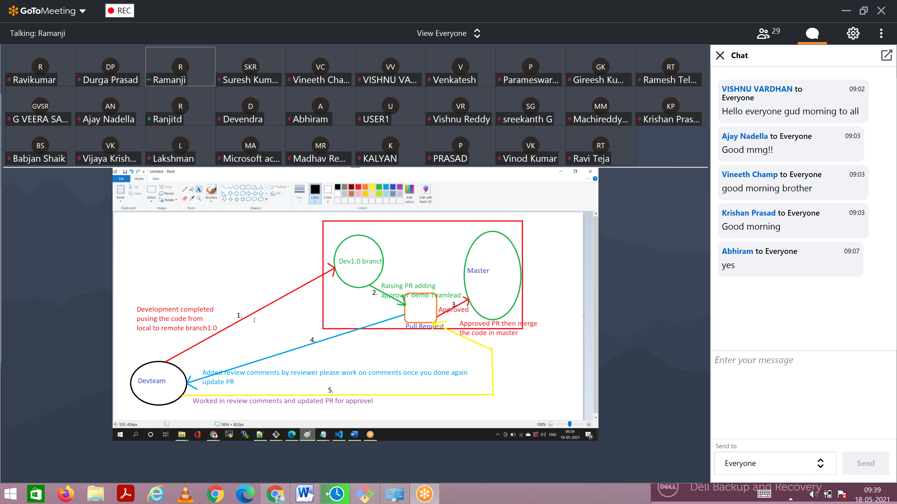

Merge Conflicts

ORR – how to resolve the merge conflicts

1. When we are working on branches, once development is completed we used to merge the changes from specific branch to master branch.
2. When we are doing the merging if I don’t have up to date code in my branch then I will get the merge conflicts. To overcome merge conflicts we are copying the code manually from master branch to my specific branch then I will merge the changes from my specific branch to master branch.